**REPORT #PAC-24-02**

To: Planning Advisory Committee

From: Richard Grant, Planner I

Date: February 8th, 2024

**Re: Application for Consent (B24-01)**

**Recommendation:**

The Planner I recommends that the Planning Advisory Committee approve Consent Application B24-01 to sever a 903 m2 (9,719.81 ft2) vacant parcel from the subject property municipally known as 241 Brockville Street, subject to the following conditions:

1. *An acceptable reference plan (survey) of the severed and retained lands and the deed or Instrument conveying the severed lands shall be submitted to the Secretary/Treasurer of the Planning Advisory Committee for review and consent endorsement* ***within a period of two years*** *after the “Notice of Decision” is given under Section 53 (17) or (24) of the Planning Act.*
2. *The owner shall supply one digital copy and two hard copies of the deposited reference plan for the severed lands.*
3. *The owner shall supply one digital and two hard copies of the deed or transfer document for the severed lands.*
4. *The balance of any outstanding taxes, including penalties and interest, shall be paid to the Town.*

**Purpose:**

**Property Information**

Address: 241 Brockville Street

Severed Lot Size: 903 m2 (9,719.81 ft2)

Retained Lot Size: 1,333 m2 (14,348.30 ft2)

Zoning: R2

OP Designation: Residential

Date of Site Visit: January 25th, 2024

The applicant has applied for a consent pursuant to Section 53.5 of the *Planning Act* to sever a 903 m2 (9,719.81 ft2) vacant parcel from the subject property municipally known as 241 Brockville Street. On the property, there is an existing single-detached dwelling situated on what would be the retained parcel.

The subject property is zoned Residential Type 2 (R2) and designated Residential in the Town’s Official Plan. The Zoning By-law permits a single-detached dwelling in the R2 Zone.

**Background:**

In January 2024, the Town received a completed consent application from solicitor Andrew Howard of Howard, Kelford and DuBois LLP on behalf of owner Bradly Plaunt.

*Consent File History*

On October 30th, 1969, the Committee of Adjustment passed conditional approval to retain a vacant parcel measuring approximately 735.80 m2 (7920 ft2) and sever the remainder of the large tract of land (originally zoned as agricultural land). The vacant parcel formed a larger piece of land measuring roughly 1471.58 m2 (15840 ft2) proposed as a road allowance, that would be an extension of Marguerite Street (west of the subject property).

On June 16th, 1970, that same vacant parcel with a 20.11 m (66 ft) frontage on Brockville Street was sold to the owner of Lot 17 (now 241 Brockville Street) to enlarge the residential property. Despite the land severance provisionally granted by the Committee of Adjustment in the 1970s, no property survey is on file to provide independent confirmation. It is in the opinion of Staff that the Committee proceed with the information provided and operate under the assumption that the information provided here is correct.

*See Schedule “A” for Key Map; Schedule “B” for Severance Site Sketch, and Schedule “C” for Part of Lot 3, CON 3 Property Survey (May 1969)*

**Land Context:**

The subject property measures approximately 43 m in depth, with a total area of 2,236 m2 and a 52 m frontage along Brockville Street. Situated on the subject property is a single-storey 1960s-era brown brick bungalow with a generous chain-linked fenced backyard , with a depth of 10 m from the main dwelling to the rear property line, a paved H-shaped driveway, and two large deciduous trees in the grassed front yard. Of the 52 m frontage along Brockville Street, the large interior side yard accounts for approximately half of the frontage, with a 26 m setback from the main dwelling. The large interior side yard is proposed to be severed by the applicant. This area is largely grassed with a few trees and a moderately steep slope that slopes towards the front lot line of the subject property (Please see Appendix D – Site Visit Photos).

The subject property Is within a residential neighbourhood comprising low to high-density residential dwellings that support various commercial and institutional uses located along Brockville Street. Low-density residential dwellings within the neighbourhood tend to have generous front yards similar to that of the subject property in question. Immediately next to the proposed severed parcel is the Salvation Army Mississippi Rideau Lakes Corps at 251 Brockville Street, which serves an institutional function in the neighbourhood. Further south along Brockville Street is the Settlers Ridge Mall, which hosts a variety of commercial and institutional uses.

The subject property is currently not subject to any other application under the *Planning Act.*

**Directing Policy:**

*Provincial Policy Statement (PPS)2200.*

Subsection 4.1 of the PPS 2020 states the Provincial Policy Statement applies to all decisions in respect of the exercise of any authority that affects a planning matter made on or after May 1, 2020

While the Provincial Policy Statement does not specifically address the mechanics and administration of lot creation, it broadly supports sufficient land to accommodate an appropriate range and mix of land uses to meet projected needs for up to 25 years. Subsection 1.1.2 of the PPS 2020 states, “Within *settlement areas, sufficient land shall be made available through intensification […]”.*

Section 1.1.3.3 specifies that intensification shall occur in appropriate locations, considering the existing built form and availability of existing or planned infrastructure and services. To that end, appropriate development standards should be promoted.

The PPS does not prescribe what is intended by “appropriate development standards,” as that is generally regulated through Zoning By-laws, which implement local priorities identified in the Official Plan.

*Smiths Falls Official Plan 2034*

The subject lands are designated Residential (*Section 6.3*) in the Town’s Official Plan, which provides for a wide range and density of residential development in established neighbourhoods, provided that this development is compatible with local characteristics.

Section LU-2.6 (Intensification) speaks to the intent of preserving the existing character of built-up areas and strictly limiting intensification to infill development that closely conforms to the prevailing existing neighbourhood character as defined by density, lot size, shape, massing, neighbourhood form and pattern.

Section 4.5 (Infrastructure) speaks to the servicing needs and priorities of the Town and stipulates that new lots shall only be created where there is sufficient water and sewer system capacity.

Comprehensive Zoning By-law 10375-2022

The broad goals outlined in the Town’s Official Plan are implemented in the regulatory Zoning By-law. Residential Type 2 (R2) is the zoning category that accommodates low and medium residential development. This Zone generally permits a variety of housing forms, including single-detached, semi-detached, and duplex dwellings, as well as some institutional uses.

The proposed severed and retained parcels comply with the lot size and frontage requirements stipulated for residential buildings within the R2 zone (see Appendix B- Severance Site Sketch).

**Public and Agency Feedback Received:**

As of the time of the preparation of this report, only agency feedback was received:

* **Dept. of Public Works:** The Dept. of Public Works does not object to this proposal.For any proposed development, [they] recommend removing the large cedar tree at the corner of the lot closest to Brockville Street (on the proposed severed lot) to improve sight lines and facilitate vehicular access to the site. It should be noted that this comment is not intended to be a condition of consent approval; it is just a comment on pre-development concerning the proposed development.
* **Chief Building Official** (C.B.O.): The CBO does not object to this proposal and has no comments.

**Review:**

Pursuant to Section 53 of the Planning Act, the approval authority may give consent to sever if the application conforms with all applicable land use policies, is not premature, and is *“satisfied that a plan of subdivision of the land is not necessary for the proper and orderly development of the municipality,”* as per **Section 7.1.6** of the Official Plan.)

With a request to sever the subject property, the proposal has been reviewed below with the following criteria:

* Conformity with the Official Plan and Zoning Bylaw
* Compatibility with neighbouring land uses
* Adequacy of vehicular access, water supply and sewage disposal
* Suitability of the land for the proposed use (including size and shape of the lot being created)

Conformity with the Official Plan and Zoning By-law

The subject property is designated Residential and zoned Residential Type 2. For context, it should be noted that properties fronting Brockville Street are zoned Residential Type 2,

which encourages general conformity within the built environment regarding the built form and massing for low to medium-density residential uses (e.g., single-detached to triplexes) and some non-residential uses such as places of worship (e.g., churches). The Official Plan designation and zoning provide some planning context for the evolution of the existing neighbourhood with regard to intensification, encouraging infill development so long as it generally conforms to the character of the existing neighbourhood both in urban design, lot size, density and neighbourhood form.

The applicants have not articulated any plans for future development at this time as part of this application. As such, the vacant lot is being evaluated as a residential lot. The proposed severed lot measuring 903 m2 far exceeds the minimum lot size of 420 m2 for a single-detached dwelling. The proposed severed lot conforms with the Official Plan and Zoning Bylaw as the existing residential use has not changed, and the size of the proposed lot is sufficient to support residential development, which, at minimum, could be a single-detached dwelling. Concerning residential density, being in the Residential Type 2 zone, there is the capacity to accommodate a wide range of housing types, from single detached to triplexes. More to the point, most residential dwellings along Brockville Street demonstrate a prevailing propensity for low-density development. However, given the size of the lots, there is the potential for increased residential density within the neighbourhood.

The nature and degree of conformity with the Official Plan and Zoning Bylaw can only be further assessed with a proposal for a planned development on the site. A well-articulated development proposal would be judged on the merits of conforming to the established character of the neighbourhood on the basis of urban design, lot size, density and neighbourhood pattern. Staff are of the opinion that the proposed severed lot demonstrates conformity with the Official Plan and the Zoning Bylaw. Staff also recommend that the applicant consider the planning context for any planned development to ensure conformity with the established built form and the overarching goal of residential intensification as articulated for the Residential Designation in the Official Plan and the Residential Type 2 zone.

Compatibility with Neighbouring Land Uses

The existing neighbouring land uses range from residential to institutional and commercial.

To the immediate south of the subject property is a property zoned for institutional uses at 251 Brockville Street (the Salvation Army Mississippi Rideau Lakes Corps), and to the north and east are residential uses. Future development on the site will have to be cognizant both in the massing and urban design of the existing uses. Given the existing residential use of the subject property and the predominantly residential nature of the neighbourhood, future development of the site would be recommended to keep the established street presence and utilize a compact urban form to maintain the overall residential character of the neighbourhood. The presence of the Salvation Army Mississippi Rideau Lakes Corps immediately south of the subject property does not pose any anticipated compatibility issues. Institutional uses are supported in the Town’s Official Plan and Zoning Bylaw in designated residential zones.

The subject property is zoned Residential Type 2, which accommodates a higher range of residential densities and housing typologies, from single detached to multiple dwellings. (Multiple dwellings are defined in the Town’s Zoning Bylaw as dwellings with three or more dwelling units, such as a triplex or quadplex). As a vacant lot absent of any planned future development, given the existing mix of higher-density residential uses and nearby commercial and institutional uses found within the neighbourhood, Staff are of the opinion that the proposed severed lot demonstrates general compatibility with neighbouring land uses.

Adequacy of Vehicular Access, Water and Sewage Servicing Connection

A tabletop exercise reviewing the water and wastewater service connections demonstrates that both service connections are available on Brockville Street for future development on the proposed severed lot. Some sightline challenges exist when entering the property via the paved driveway (located on the retained parcel). During a preliminary conversation with the Department of Public Works on the adequacy of vehicular access, they believe that the lot is accessible. However, they recommended the removal of the large cedar tree on the corner of the lot closest to Brockville Street within the municipal right of way. Removing the large cedar tree will address safety concerns over egress and ingress onto the site. A curb cut would also be required to facilitate vehicular access for future development. Staff recommend that if the property is to be developed, the large cedar tree be removed and a curb cut installed along the frontage of the proposed severed lot. It should be noted that the applicants at this time have no plans for redeveloping the lot, and comments regarding its future redevelopment are only provided to satisfy a hypothetical scenario for the purposes of this assessment.

Land Suitability

The proposed severed lot is more than twice the size of the minimum lot size requirements for a single-detached residential dwelling in the Residential Type 2 zone at 420 m2 (4,520.84 ft2). This suggests there is capacity to accommodate residential development, which, at minimum, could be a single-detached dwelling; however, it may accommodate a higher density form of development. Absent a proposal for any planned development on the proposed severed lot, the suitability of the land remains thoroughly untested. However, given the size of the lot at 903 m2 (9,6907.50 ft2), its location on Brockville Street, the current Residential Type 2 zoning, the current neighbourhood context and the presence of water and wastewater servicing connections, the vacant lot could be suitable for various purposes. For the sake of this assessment, Staff are of the opinion that the proposed severed lot demonstrates a high degree of potential suitability for development. However, future works would be required to ground truth this site assessment at the time of a building application, as there are other considerations to be evaluated, such as density and parking provisions.

**Recommendation:**

The Planning Advisory Committee is tasked with making a decision on the application as presented. Based on a review of applicable governing policies and consideration of the intricacies of application B24-01, planning staff are of the view that a severance to divide the lot at 241 Brockville Street into two new parcels broadly meets the intent of the PPS 2020 and the Town’s Official Plan 2034 in policy and can be given favourable consideration by the Committee. As such, staff recommend that the Committee approve the consent application, subject to the conditions outlined on the first page of this report.

Respectfully Submitted: Reviewed and Approved:

*Original Signed Original Signed*

Richard Grant Karl Grenke RPP, MCIP

Planner I Manager of Development Services

**APPENDIX A – Context Map**

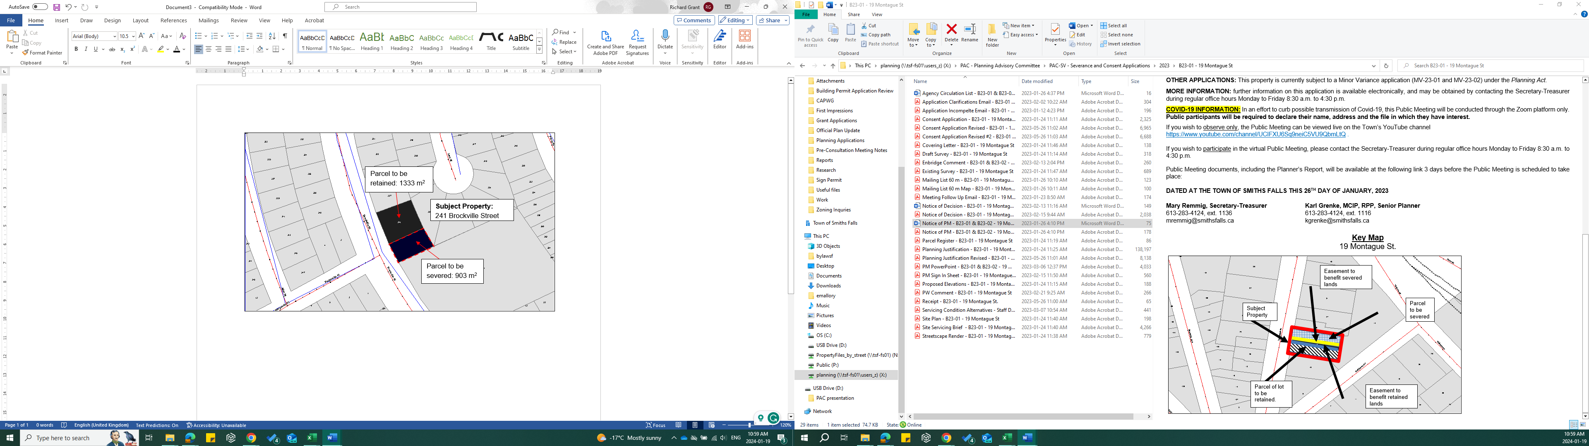

**APPENDIX B- Property Sketch**

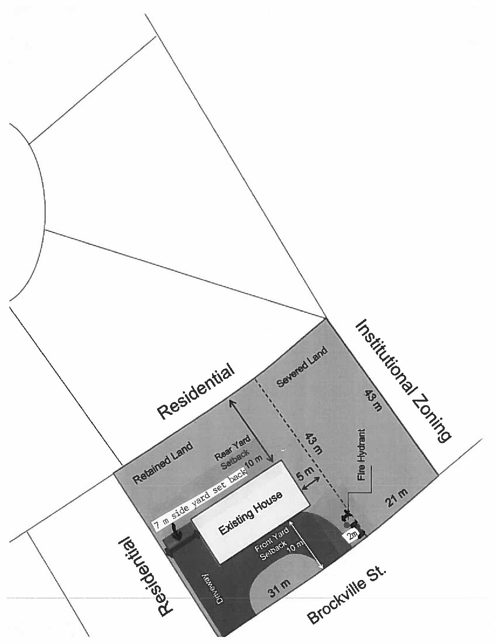

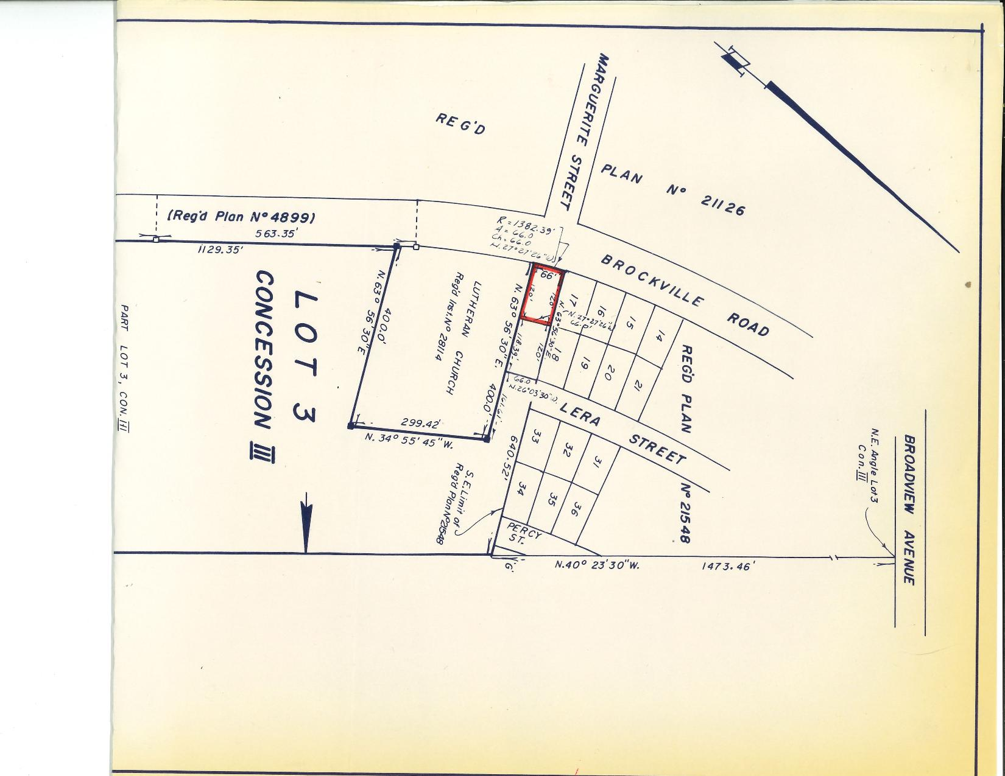**APPENDIX C – Part of Lot 3 CON 3 Property Survey (1969)**

**APPENDIX D – Site Visit Photos [Date]**

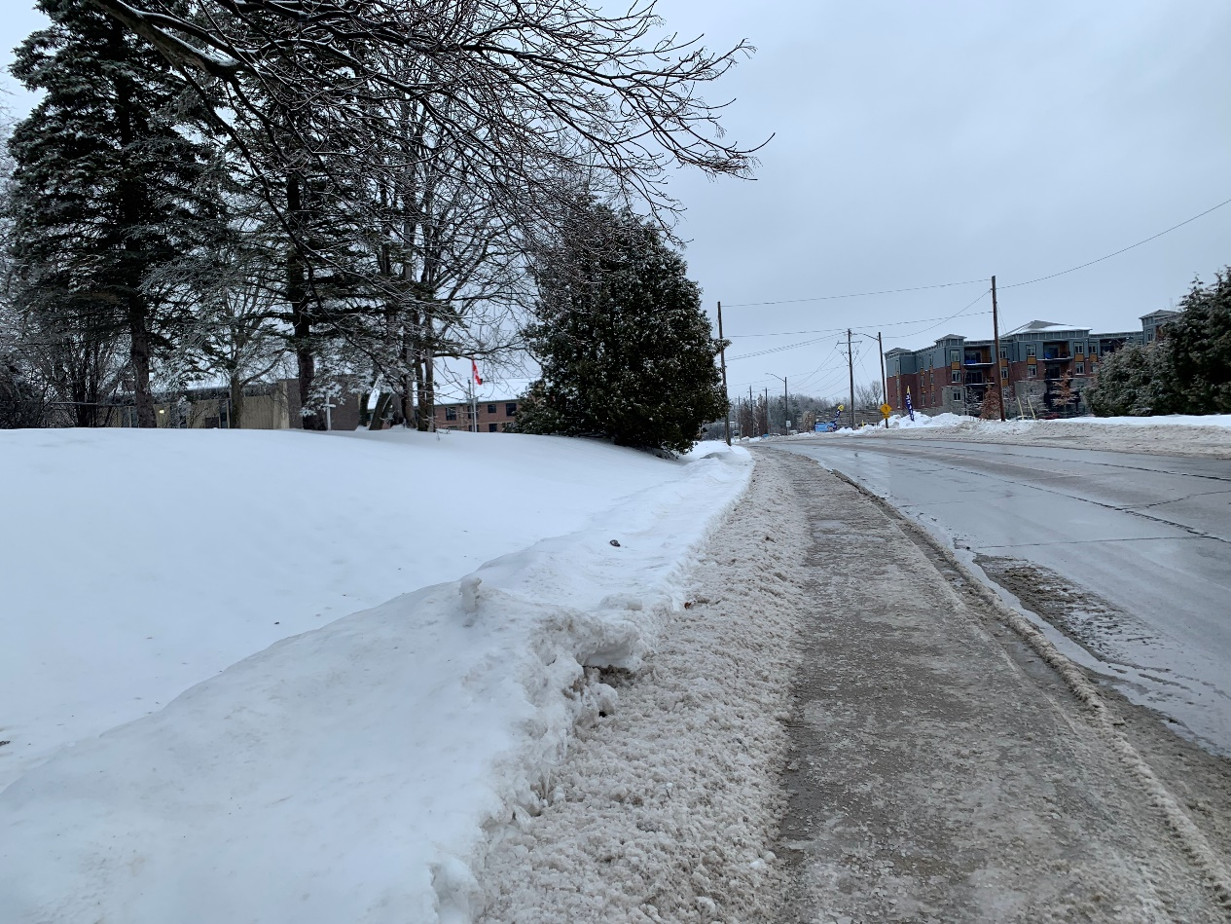

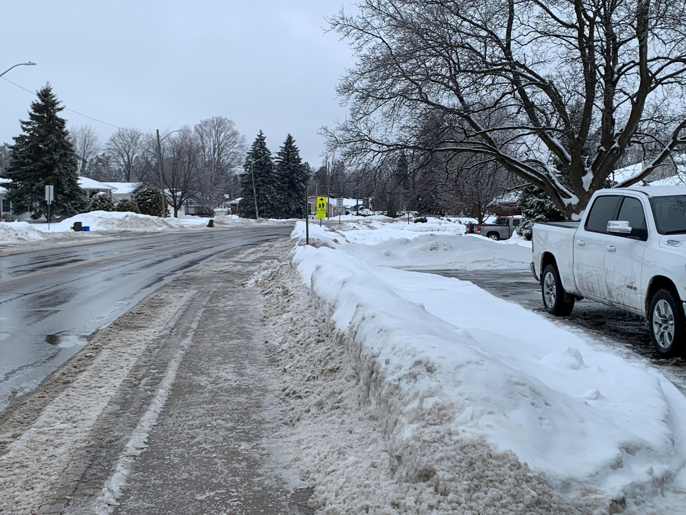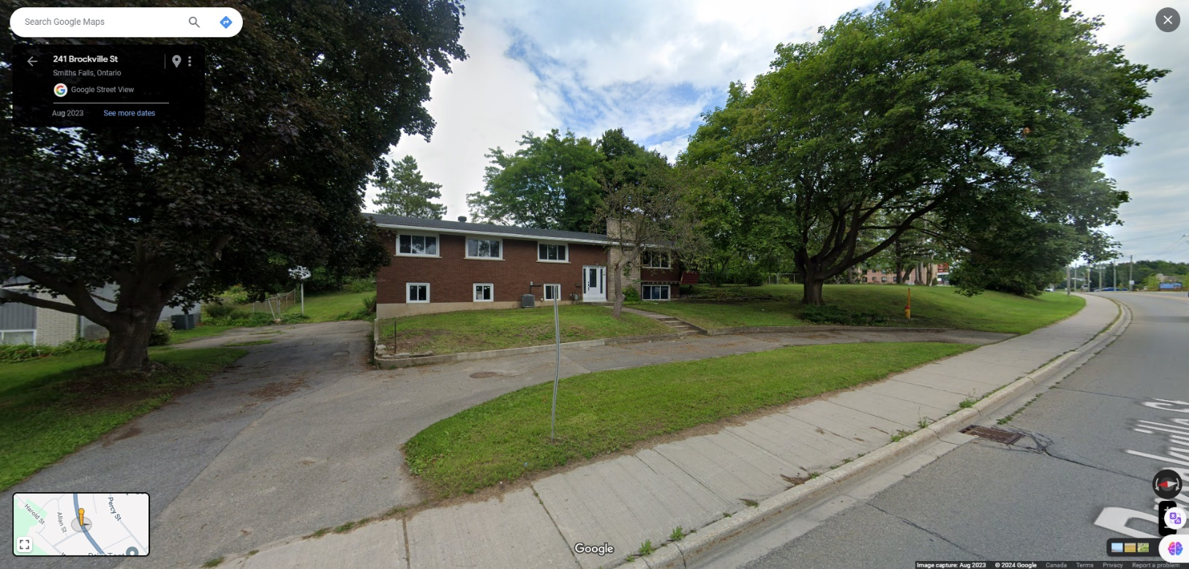

*Source: Google Maps, 2024*

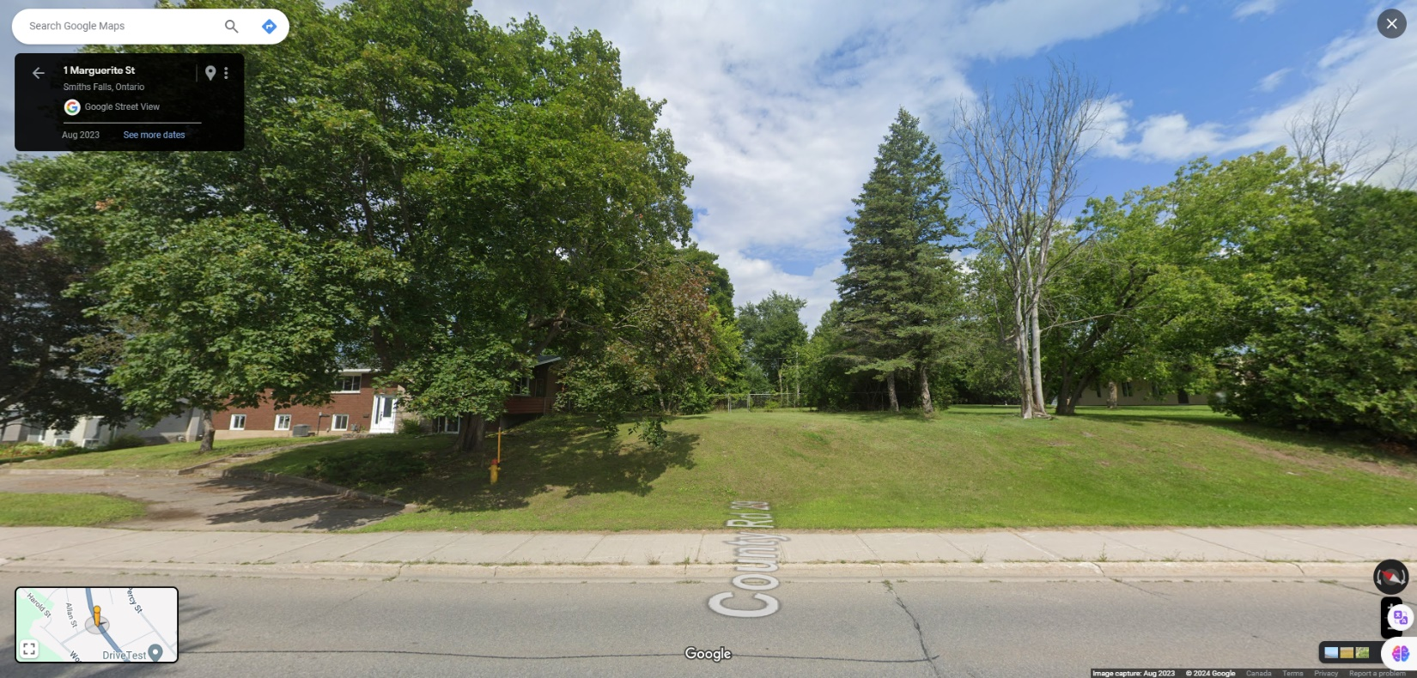

*Source: Google Maps, 2024*